Chapter 25
Option Valuation

Multiple Choice Questions
1. Travis owns a stock that is currently valued at $45.80 a share. He is concerned that the stock price may decline so he just purchased a put option on the stock with an exercise price of $45. Which one of the following terms applies to the strategy Travis is using?
A. put-call parity
B. covered call
C. protective put
D. straddle
E. strangle

2. Put-call parity is defined as the relationship between which of the following variables?
I. risk-free asset
II. underlying stock price
III. call option
IV. put option
A. I and II only
B. II and III only
C. II, III, and IV only
D. I, II, and III only
E. I, II, III, and IV

3. Assume the price of Westward Co. stock increases by one percent. Which one of the following measures the effect that this change in the stock price will have on the value of the Westward Co. options?
A. theta
B. vega
C. rho
D. delta
E. gamma

4. Which one of the following defines the relationship between the value of an option and the option's time to expiration?
A. theta.
B. vega.
C. rho.
D. delta.
E. gamma.

5. Assume the standard deviation of the returns on ABC stock increases. The effect of this change on the value of the call options on ABC stock is measured by which one of the following?
A. theta.
B. vega.
C. rho.
D. delta.
E. gamma.

6. The sensitivity of an option's value to a change in the risk-free rate is measured by which one of the following?
A. theta.
B. vega.
C. rho.
D. delta.
E. gamma.

7. The implied volatility of the returns on the underlying asset that is computed using the Black-Scholes option pricing model is referred to as which one of the following?
A. residual error
B. implied mean return
C. derived case volatility (DCV)
D. forecast rho
E. implied standard deviation (ISD)

8. Amy just purchased a right to buy 100 shares of LKL stock for $35 a share on June 20, 2009. Which one of the following did Amy purchase?
A. American delta
B. American call
C. American put
D. European put
E. European call

9. Which one of the following provides the option of selling a stock anytime during the option period at a specified price even if the market price of the stock declines to zero?
A. American call
B. European call
C. American put
D. European put
E. either an American or a European put

10. Which one of the following best defines the primary purpose of a protective put?
A. ensure a maximum purchase price in the future
B. offset an equivalent call option
C. limit the downside risk of asset ownership
D. lock in a risk-free rate of return on a financial asset
E. increase the upside potential return on an investment

11. Which one of the following acts like an insurance policy if the price of a stock you own suddenly decreases in value?
A. sale of a European call option
B. sale of an American put option
C. purchase of a protective put
D. purchase of a protective call
E. either the sale or purchase of a put

12. Which one of the following can be used to replicate a protective put strategy?
A. riskless investment and stock purchase
B. stock purchase and call option
C. call option and riskless investment
D. riskless investment
E. call option, stock purchase, and riskless investment

13. Given the (1) exercise price E, (2) time to maturity T, and (3) European put-call parity, the present value of E plus the value of the call option is equal to the:
A. current market value of the stock.
B. present value of the stock minus the value of the put.
C. value of the put minus the market value of the stock.
D. value of a risk-free asset.
E. stock value plus the put value.

14. Which one of the following will provide you with the same value that you would have if you just purchased BAT stock?
A. sell a put option on BAT stock and invest at the risk-free rate of return
B. buy both a call option and a put option on BAT stock and also lend out funds at the risk-free rate
C. sell a put and buy a call on BAT stock as well as invest at the risk-free rate of return
D. lend out funds at the risk-free rate of return and sell a put option on BAT stock
E. borrow funds at the risk-free rate of return and invest the proceeds in equivalent amounts of put and call options on BAT stock

15. Under European put-call parity, the present value of the strike price is equivalent to:
A. the current value of the stock minus the call premium.
B. the market value of the stock plus the put premium.
C. the present value of a government coupon bond with a face value equal to the strike price.
D. a U.S. Treasury bill with a face value equal to the strike price.
E. a risk-free security with a face value equal to the strike price and a coupon rate equal to the risk-free rate of return.

16. Traci wants to have $16,000 six years from now and wants to deposit just one lump sum amount today. The annual percentage rate applicable to her investment is 6.8 percent. Which one of the following methods of compounding interest will allow her to deposit the least amount possible today?
A. annual
B. daily
C. quarterly
D. monthly
E. continuous

17. The seller of a European call option has the:
A. right, but not the obligation, to buy a stock at a specified price on a specified date.
B. right to buy a stock at a specified price during a specified period of time.
C. obligation to sell a stock on a specified date but only at the specified price.
D. obligation to buy a stock some time during a specified period at the specified price.
E. obligation to buy a stock at the lower of the exercise price or the market price on the expiration date.

18. In the Black-Scholes option pricing formula, N(d₁) is the probability that a standardized, normally distributed random variable is:
A. less than or equal to N(d₂).
B. less than one.
C. equal to one.
D. equal to d₁.
E. less than or equal to d₁.

19. In the Black-Scholes model, the symbol "σ" is used to represent the standard deviation of the:
A. option premium on a call with a specified exercise price.
B. rate of return on the underlying asset.
C. volatility of the risk-free rate of return.
D. rate of return on a risk-free asset.
E. option premium on a put with a specified exercise price.

20. Which of the following affect the value of a call option?
I. strike price
II. time to maturity
III. standard deviation of the returns on a risk-free asset
IV. risk-free rate
A. I and III only
B. II and IV only
C. I, II, and IV only
D. II, III, and IV only
E. I, II, III, and IV

21. To compute the value of a put using the Black-Scholes option pricing model, you:
A. first have to apply the put-call parity relationship.
B. first have to compute the value of the put as if it is a call.
C. compute the value of an equivalent call and then subtract that value from one.
D. compute the value of an equivalent call and then subtract that value from the market price of the stock.
E. compute the value of an equivalent call and then multiply that value by e^{-RT}.

22. Which one of the following statements is correct?
A. The price of an American put is equal to the stock price minus the exercise price.
B. The value of a European call is greater than the value of a comparable American call.
C. The value of a put is equal to one minus the value of an equivalent call.
D. The value of a put minus the value of a comparable call is equal to the value of the stock minus the exercise price.
E. The value of an American put will equal or exceed the value of a comparable European put.

23. The Black-Scholes option pricing model can be used for:
A. American options but not European options.
B. European options but not American options.
C. call options but not put options.
D. put options but not call options.
E. both zero coupon bonds and coupon bonds.

24. Which of the following variables are included in the Black-Scholes call option pricing formula?
I. put premium
II. N(d₁)
III. exercise price
IV. stock price
A. III and IV only
B. I, II, and IV only
C. II, III, and IV only
D. I, III, and IV only
E. I, II, III, and IV

25. Which one of the following statements related to options is correct?
A. American stock options can be exercised but not resold.
B. A European call is either equal to or less valuable than a comparable American call.
C. European puts can be resold but can never be exercised.
D. European options can be exercised on any dividend payment date.
E. American options are valued using the Black-Scholes option pricing model.

26. The value of a call option delta is best defined as:
A. between zero and one.
B. less than zero.
C. greater than zero.
D. greater than or equal to zero.
E. greater than one.

27. Which one of the following is the correct formula for approximating the change in an option's value given a small change in the value of the underlying stock?
A. Change in option value ≈ Change in stock value/Delta
B. Change in option value ≈ Change in stock value/(1 - Delta)
C. Change in option value ≈ Change in stock value/(1 + Delta)
D. Change in option value ≈ Change in stock value × (1 - Delta)
E. Change in option value ≈ Change in stock value × Delta

28. Assume the price of the underlying stock decreases. How will the values of the options respond to this change?
I. call value decreases
II. call value increases
III. put value decreases
IV. put value increases
A. I and III only
B. I and IV only
C. II and III only
D. II and IV only
E. I only

29. Which of the following statements are correct?
I. Increasing the time to maturity may not increase the value of a European put.
II. Vega measures the sensitivity of an option's value to the passage of time.
III. Call options tend to be more sensitive to the passage of time than are put options.
IV. An increase in time decreases the value of a call option.
A. I and III only
B. II and IV only
C. II, III, and IV only
D. I, III, and IV only
E. I, II, III, and IV

30. Theta measures an option's:
A. intrinsic value.
B. volatility.
C. rate of time decay.
D. sensitivity to changes in the value of the underlying asset.
E. sensitivity to risk-free rate changes.

31. Selling an option is generally more valuable than exercising the option because of the option's:
A. riskless value.
B. intrinsic value.
C. standard deviation.
D. exercise price.
E. time premium.

32. Which of the following statements are correct?
I. As the standard deviation of the returns on a stock increase, the value of a put option increases.
II. The value of a call option decreases as the time to expiration increases.
III. A decrease in the risk-free rate increases the value of a put option.
IV. Increasing the strike price increases the value of a put option.
A. I and III only
B. II and IV only
C. I and II only
D. I, III, and IV only
E. I, II, and III only

33. A decrease in which of the following will increase the value of a put option on a stock?
I. time to expiration
II. stock price
III. exercise price
IV. risk-free rate
A. III only
B. II and IV only
C. I and III only
D. I, II, and III only
E. II, III, and IV only

34. Which one of the five factors included in the Black-Scholes model cannot be directly observed?
A. risk-free rate
B. strike price
C. standard deviation
D. stock price
E. life of the option

35. Which one of the following statements related to the implied standard deviation (ISD) is correct?
A. The ISD is an estimate of the historical standard deviation of the underlying security.
B. ISD is equal to (1 - D₁).
C. The ISD estimates the volatility of an option's price over the option's lifespan.
D. The value of ISD is dependent upon both the risk-free rate and the time to option expiration.
E. ISD confirms the observable volatility of the return on the underlying security.

36. The implied standard deviation used in the Black-Scholes option pricing model is:
A. based on historical performance.
B. a prediction of the volatility of the return on the underlying asset over the life of the option.
C. a measure of the time decay of an option.
D. an estimate of the future value of an option given a strike price (E).
E. a measure of the historical intrinsic value of an option.

37. The value of an option is equal to the:
A. intrinsic value minus the time premium.
B. time premium plus the intrinsic value.
C. implied standard deviation plus the intrinsic value.
D. summation of the intrinsic value, the time premium, and the implied standard deviation.
E. summation of delta, theta, vega, and rho.

38. For the equity of a firm to be considered a call option on the firm's assets, the firm must:
A. be in default.
B. be leveraged.
C. pay dividends.
D. have a negative cash flow from operations.
E. have a negative cash flow from assets.

39. Paying off a firm's debt is comparable to _____ on the assets of the firm.
A. purchasing a put option
B. purchasing a call option
C. exercising an in-the-money put option
D. exercising an in-the-money call option
E. selling a call option

40. The shareholders of a firm will benefit the most from a positive net present value project when the delta of the call option on the firm's assets is:
A. equal to one.
B. between zero and one.
C. equal to zero.
D. between zero and minus one.
E. equal to minus one.

41. The value of the risky debt of a firm is equal to the value of:
A. a call option plus the value of a risk-free bond.
B. a risk-free bond plus a put option.
C. the equity of the firm minus a put.
D. the equity of the firm plus a call option.
E. a risk-free bond minus a put option.

42. A firm has assets of $21.8 million and a 3-year, zero-coupon, risky bonds with a total face value of $8.5 million. The bonds have a total current market value of $8.1 million. How can the shareholders of this firm change these risky bonds into risk-free bonds?
A. purchase a call option with a 1-year life and a $8.1 million face value
B. purchase a call option with a 5-year life and a $8.5 million face value
C. purchase a put option with a 1-year life and a $21.8 million face value
D. purchase a put option with a 3-year life and a $8.1 million face value
E. purchase a put option with a 3-year life and an $8.5 million face value

43. Pure financial mergers:
A. are beneficial to stockholders.
B. are beneficial to both stockholders and bondholders.
C. are detrimental to stockholders.
D. add value to both the total assets and the total equity of a firm.
E. reduce both the total assets and the total equity of a firm.

44. A purely financial merger:
A. increases the risk that the merged firm will default on its debt obligations.
B. has no effect on the risk level of the firm's debt.
C. reduces the value of the option to go bankrupt.
D. has no effect on the equity value of a firm.
E. reduces the risk level of the firm and increases the value of the firm's equity.

45. Which one of the following statements is correct?
A. Mergers benefit shareholders but not creditors.
B. Positive NPV projects will automatically benefit both creditors and shareholders.
C. Shareholders might prefer a negative NPV project over a positive NPV project.
D. Creditors prefer negative NPV projects while shareholders prefer positive NPV projects.
E. Mergers rarely affect bondholders.

46. This morning, Krystal purchased shares of Global Markets stock at a cost of $39.40 per share. She simultaneously purchased puts on Global Markets stock at a cost of $1.25 per share and a strike price of $40 per share. The put expires in one year. How much profit will she earn per share on these transactions if the stock is worth $38 a share one year from now?
A. -$2.65
B. -$1.25
C. -$0.65
D. $0.60
E. $1.25

47. Today, you purchased 100 shares of Lazy Z stock at a market price of $47 per share. You also bought a one year, $45 put option on Lazy Z stock at a cost of $0.15 per share. What is the maximum total amount you can lose on these purchases?
A. -$4,715
B. -$4,685
C. -$4,015
D. -$215
E. -$0

48. Today, you are buying a one-year call on Piper Sons stock with a strike price of $27.50 per share and a one-year risk-free asset which pays 3.5 percent interest. The cost of the call is $1.40 per share and the amount invested in the risk-free asset is $26.57. How much total profit will you earn on these purchases if the stock has a market price of $29 one year from now?
A. $0.10
B. $0.85
C. $1.03
D. $1.11
E. $1.17

49. Today, you are buying a one-year call on one share of Webster United stock with a strike price of $40 per share and a one-year risk-free asset that pays 4 percent interest. The cost of the call is $1.85 per share and the amount invested in the risk-free asset is $38.46. What is the most you can lose on these purchases over the next year?
A. -$1.85
B. -$0.31
C. $0
D. $0.42
E. $1.54

50. A.K. Scott's stock is selling for $38 a share. A 3-month call on this stock with a strike price of $35 is priced at $3.40. Risk-free assets are currently returning 0.18 percent per month. What is the price of a 3-month put on this stock with a strike price of $35?
A. $0.21
B. $0.49
C. $4.99
D. $5.85
E. $6.20

51. Cell Tower stock has a current market price of $62 a share. The one-year call on Cell Tower stock with a strike price of $65 is priced at $7.16 while the one-year put with a strike price of $65 is priced at $7.69. What is the risk-free rate of return?
A. 3.95 percent
B. 4.21 percent
C. 4.67 percent
D. 5.38 percent
E. 5.57 percent

52. Grocery Express stock is selling for $22 a share. A 3-month, $20 call on this stock is priced at $2.65. Risk-free assets are currently returning 0.2 percent per month. What is the price of a 3-month put on Grocery Express stock with a strike price of $20?
A. $0.37
B. $0.53
C. $0.67
D. $1.10
E. $1.18

53. J&N, Inc. stock has a current market price of $46 a share. The one-year call on this stock with a strike price of $55 is priced at $0.05 while the one-year put with a strike price of $55 is priced at $8.24. What is the risk-free rate of return?
A. 1.49 percent
B. 1.82 percent
C. 3.10 percent
D. 3.64 percent
E. 4.21 percent

54. You invest $4,000 today at 6.5 percent, compounded continuously. How much will this investment be worth 8 years from now?
A. $6,620
B. $6,728
C. $7,311
D. $7,422
E. $7,791

55. Todd invested $8,500 in an account today at 7.5 percent compounded continuously. How much will he have in his account if he leaves his money invested for 5 years?
A. $12,203
B. $12,245
C. $12,287
D. $12,241
E. $12,367

56. Wesleyville Markets stock is selling for $36 a share. The 9-month $40 call on this stock is selling for $2.23 while the 9-month $40 put is priced at $5.11. What is the continuously compounded risk-free rate of return?
A. 2.87 percent
B. 3.11 percent
C. 3.38 percent
D. 3.56 percent
E. 3.79 percent

57. The stock of Edwards Homes, Inc. has a current market value of $23 a share. The 3-month call with a strike price of $20 is selling for $3.80 while the 3-month put with a strike price of $20 is priced at $0.54. What is the continuously compounded risk-free rate of return?
A. 4.43 percent
B. 4.50 percent
C. 4.68 percent
D. 5.00 percent
E. 5.23 percent

58. What is the value of d₂ given the following information on a stock?
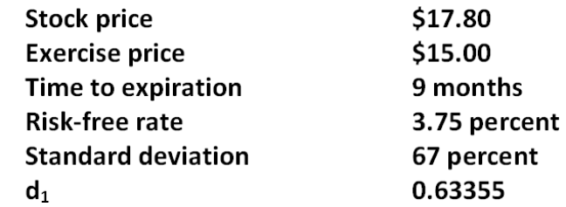
A. 0.0518
B. 0.0525
C. 0.0533
D. 0.0535
E. 0.0540

59. Given the following information, what is the value of d₂ as it is used in the Black-Scholes option pricing model?
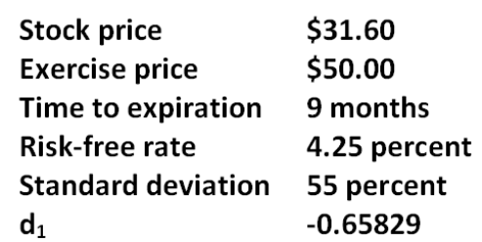
A. -1.1346
B. -0.8657
C. -0.8241
D. -0.7427
E. -0.7238

60. What is the value of a 3-month call option with a strike price of $25 given the Black-Scholes option pricing model and the following information?
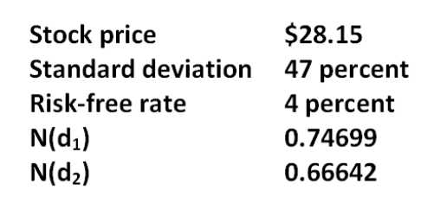
A. $3.38
B. $3.42
C. $3.68
D. $4.27
E. $4.53

61. What is the value of a 6-month call with a strike price of $25 given the Black-Scholes option pricing model and the following information?
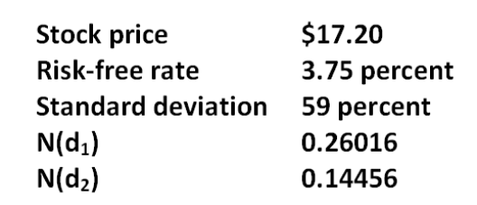
A. $0
B. $0.93
C. $1.06
D. $1.85
E. $2.14

62. What is the value of a 6-month put with a strike price of $27.50 given the Black-Scholes option pricing model and the following information?
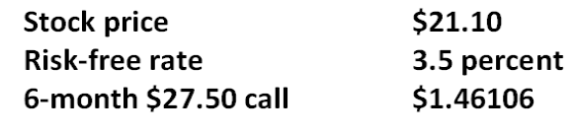
A. $6.71
B. $6.88
C. $7.24
D. $7.38
E. $7.62

63. What is the value of a 3-month put with a strike price of $45 given the Black-Scholes option pricing model and the following information?
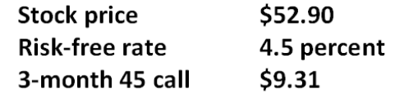
A. $0.57
B. $0.63
C. $0.91
D. $1.36
E. $1.54

64. A stock is currently selling for $55 a share. The risk-free rate is 4 percent and the standard deviation is 18 percent. What is the value of d₁ of a 9-month call option with a strike price of $57.50?
A. -0.01506
B. -0.01477
C. -0.00574
D. 0.00042
E. 0.00181

65. A stock is currently selling for $36 a share. The risk-free rate is 3.8 percent and the standard deviation is 27 percent. What is the value of d₁ of a 9-month call option with a strike price of $40?
A. -0.21872
B. -0.21179
C. -0.21047
D. -0.20950
E. -0.20356

66. The delta of a call option on a firm's assets is 0.767. This means that a $50,000 project will increase the value of equity by:
A. $21,760.
B. $25,336.
C. $38,350.
D. $54,627.
E. $65,189.

67. The delta of a call option on a firm's assets is 0.727. This means that a $195,000 project will increase the value of equity by:
A. $141,765.
B. $180,219.
C. $211,481.
D. $264,909.
E. $268,226.

68. The current market value of the assets of Smethwell, Inc. is $56 million, with a standard deviation of 16 percent per year. The firm has zero-coupon bonds outstanding with a total face value of $40 million. These bonds mature in 2 years. The risk-free rate is 4.5 percent per year compounded continuously. What is the value of d₁?
A. 1.67
B. 1.84
C. 1.93
D. 2.00
E. 2.06

69. The current market value of the assets of Cristopherson Supply is $46.5 million. The market value of the equity is $28.7 million. The risk-free rate is 4.75 percent and the outstanding debt matures in 4 years. What is the market value of the firm's debt?
A. $17.80 million
B. $19.80 million
C. $20.23 million
D. $22.66 million
E. $23.01 million

70. The current market value of the assets of Nano Tek is $16 million. The market value of the equity is $7.5 million. The risk-free rate is 4.5 percent and the outstanding debt matures in 5 years. What is the market value of the firm's debt?
A. $8.50 million
B. $9.98 million
C. $12.00 million
D. $19.42 million
E. $23.84 million

Essay Questions
71. Explain why the equity ownership of a firm is equivalent to owning a call option on the firm's assets.

72. Explain how option pricing theory can be used to argue that acquisitive firms pursuing conglomerate mergers are not acting in the shareholders' best interest.

73. Give an example of a protective put and explain how this strategy reduces investor risk.

74. Identify the five variables that affect the value of an American put option and indicate how an increase in each of the variables will affect the value of the put. Also indicate the common name, if any, given to each variable.

75. Explain how an increase in T-bill rates will affect the value of an American call and an American put.

76. Explain why financial mergers tend to benefit bondholders more than shareholders.

Multiple Choice Questions
77. You need $12,000 in 6 years. How much will you need to deposit today if you can earn 11 percent per year, compounded continuously? Assume this is the only deposit you make.
A. $6,000.00
B. $6,048.50
C. $6,179.25
D. $6,202.22
E. $6,415.69

78. A stock is selling for $60 per share. A call option with an exercise price of $67 sells for $3.31 and expires in 4 months. The risk-free rate of interest is 2.8 percent per year, compounded continuously. What is the price of a put option with the same exercise price and expiration date?
A. $8.99
B. $9.23
C. $9.47
D. $9.69
E. $9.94

79. A put option that expires in eight months with an exercise price of $57 sells for $3.85. The stock is currently priced at $59, and the risk-free rate is 3.1 percent per year, compounded continuously. What is the price of a call option with the same exercise price and expiration date?
A. $6.67
B. $7.02
C. $7.34
D. $7.71
E. $7.80

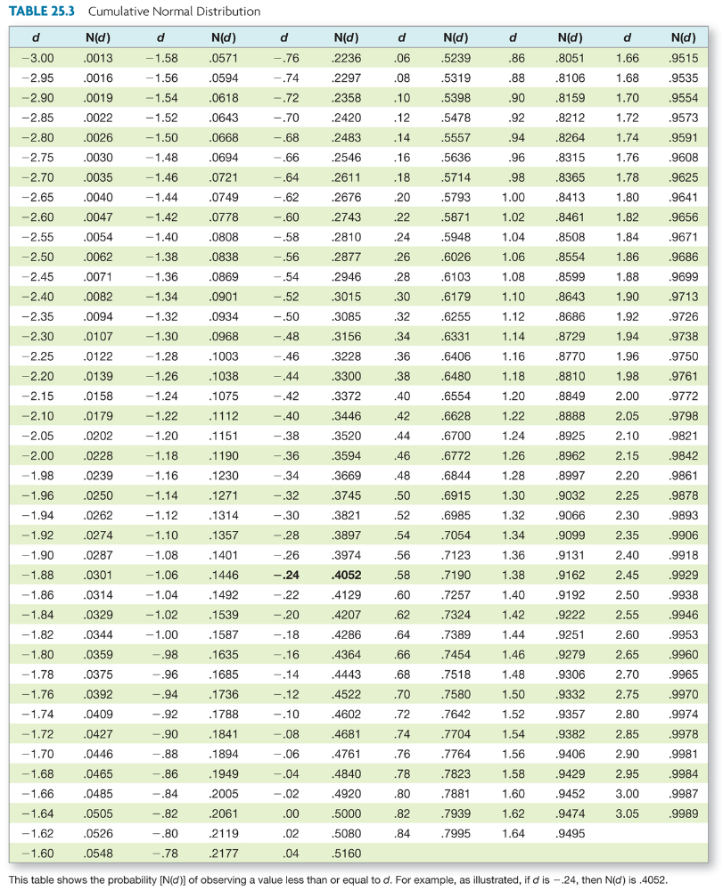

80. What is the price of a put option given the following information?
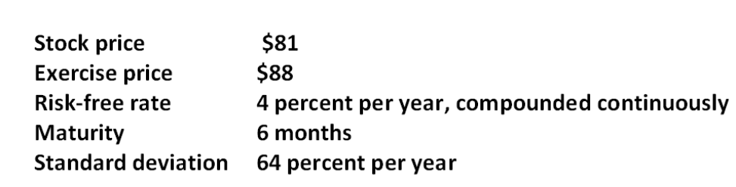
A. $16.57
B. $16.83
C. $17.74
D. $18.47
E. $19.02

81. What is the delta of a put option given the following information?
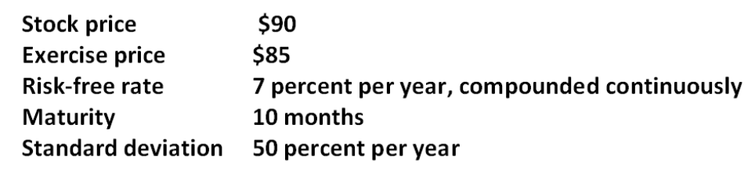
A. -0.685
B. -0.315
C. 0.315
D. 0.525
E. 0.685

82. You own a lot in Key West, Florida, that is currently unused. Similar lots have recently sold for $1.2 million. Over the past five years, the price of land in the area has increased 10 percent per year, with an annual standard deviation of 23 percent. A buyer has recently approached you and wants an option to buy the land in the next 9 months for $1,310,000. The risk-free rate of interest is 7 percent per year, compounded continuously. How much should you charge for the option? (Round your answer to the nearest $1,000.)
A. $52,000
B. $58,000
C. $63,000
D. $72,000
E. $77,000

83. A call option with an exercise price of $31 and 6 months to expiration has a price of $3.77. The stock is currently priced at $17.99, and the risk-free rate is 3 percent per year, compounded continuously. What is the price of a put option with the same exercise price and expiration date?
A. $13.89
B. $14.57
C. $15.24
D. $15.69
E. $16.32

84. A call option matures in nine months. The underlying stock price is $95, and the stock's return has a standard deviation of 19 percent per year. The risk-free rate is 3 percent per year, compounded continuously. The exercise price is $0. What is the price of the call option?
A. $15.97
B. $52.14
C. $56.37
D. $92.23
E. $95.00

85. A stock is currently priced at $45. A call option with an expiration of one year has an exercise price of $60. The risk-free rate is 14 percent per year, compounded continuously, and the standard deviation of the stock's return is infinitely large. What is the price of the call option?
A. $39.47
B. $42.08
C. $45.00
D. $52.63
E. $60.00

86. Sunburn Sunscreen has a zero coupon bond issue outstanding with a $10,000 face value that matures in one year. The current market value of the firm's assets is $10,600. The standard deviation of the return on the firm's assets is 40 percent per year, and the annual risk-free rate is 7 percent per year, compounded continuously. What is the market value of the firm's debt based on the Black-Scholes model? (Round your answer to the nearest $100.)
A. $6,415.30
B. $6,900
C. $8,300
D. $8,800
E. $9,200

87. Frostbite Thermal Wear has a zero coupon bond issue outstanding with a face value of $20,000 that matures in one year. The current market value of the firm's assets is $23,000. The standard deviation of the return on the firm's assets is 52 percent per year, and the annual risk-free rate is 6 percent per year, compounded continuously. What is the market value of the firm's equity based on the Black-Scholes model? (Round your answer to the nearest $100.)
A. $6,400
B. $6,700
C. $6,900
D. $7,000
E. $7,200

Chapter 25 Option Valuation Answer Key

Multiple Choice Questions
1. Travis owns a stock that is currently valued at $45.80 a share. He is concerned that the stock price may decline so he just purchased a put option on the stock with an exercise price of $45. Which one of the following terms applies to the strategy Travis is using?
A. put-call parity
B. covered call
C. protective put
D. straddle
E. strangle
Refer to section 25.1

AACSB: N/A
Bloom's: Knowledge
Difficulty: Basic
Learning Objective: 25-1
Section: 25.1
Topic: Protective put
2. Put-call parity is defined as the relationship between which of the following variables?
I. risk-free asset
II. underlying stock price
III. call option
IV. put option
A. I and II only
B. II and III only
C. II, III, and IV only
D. I, II, and III only
E. I, II, III, and IV
Refer to section 25.1

AACSB: N/A
Bloom's: Knowledge
Difficulty: Basic
Learning Objective: 25-1
Section: 25.1
Topic: Put-call parity
3. Assume the price of Westward Co. stock increases by one percent. Which one of the following measures the effect that this change in the stock price will have on the value of the Westward Co. options?
A. theta
B. vega
C. rho
D. delta
E. gamma
Refer to section 25.3

AACSB: N/A
Bloom's: Knowledge
Difficulty: Basic
Learning Objective: 25-3
Section: 25.3
Topic: Option delta
4. Which one of the following defines the relationship between the value of an option and the option's time to expiration?
A. theta.
B. vega.
C. rho.
D. delta.
E. gamma.
Refer to section 25.3

AACSB: N/A
Bloom's: Knowledge
Difficulty: Basic
Learning Objective: 25-3
Section: 25.3
Topic: Option theta
5. Assume the standard deviation of the returns on ABC stock increases. The effect of this change on the value of the call options on ABC stock is measured by which one of the following?
A. theta.
B. vega.
C. rho.
D. delta.
E. gamma.
Refer to section 25.3

AACSB: N/A
Bloom's: Knowledge
Difficulty: Basic
Learning Objective: 25-3
Section: 25.3
Topic: Option vega
6. The sensitivity of an option's value to a change in the risk-free rate is measured by which one of the following?
A. theta.
B. vega.
C. rho.
D. delta.
E. gamma.
Refer to section 25.3

AACSB: N/A
Bloom's: Knowledge
Difficulty: Basic
Learning Objective: 25-3
Section: 25.3
Topic: Option rho
7. The implied volatility of the returns on the underlying asset that is computed using the Black-Scholes option pricing model is referred to as which one of the following?
A. residual error
B. implied mean return
C. derived case volatility (DCV)
D. forecast rho
E. implied standard deviation (ISD)
Refer to section 25.3

AACSB: N/A
Bloom's: Knowledge
Difficulty: Basic
Learning Objective: 25-3
Section: 25.3
Topic: Implied standard deviation
8. Amy just purchased a right to buy 100 shares of LKL stock for $35 a share on June 20, 2009. Which one of the following did Amy purchase?
A. American delta
B. American call
C. American put
D. European put
E. European call
Refer to section 25.1

AACSB: N/A
Bloom's: Knowledge
Difficulty: Basic
Learning Objective: 25-1
Section: 25.1
Topic: Put option
9. Which one of the following provides the option of selling a stock anytime during the option period at a specified price even if the market price of the stock declines to zero?
A. American call
B. European call
C. American put
D. European put
E. either an American or a European put
Refer to section 25.1

AACSB: N/A
Bloom's: Knowledge
Difficulty: Basic
Learning Objective: 25-1
Section: 25.1
Topic: Put option
10. Which one of the following best defines the primary purpose of a protective put?
A. ensure a maximum purchase price in the future
B. offset an equivalent call option
C. limit the downside risk of asset ownership
D. lock in a risk-free rate of return on a financial asset
E. increase the upside potential return on an investment
Refer to section 25.1

AACSB: N/A
Bloom's: Knowledge
Difficulty: Basic
Learning Objective: 25-1
Section: 25.1
Topic: Protective put
11. Which one of the following acts like an insurance policy if the price of a stock you own suddenly decreases in value?
A. sale of a European call option
B. sale of an American put option
C. purchase of a protective put
D. purchase of a protective call
E. either the sale or purchase of a put
Refer to section 25.1

AACSB: N/A
Bloom's: Comprehension
Difficulty: Basic
Learning Objective: 25-1
Section: 25.1
Topic: Protective put
12. Which one of the following can be used to replicate a protective put strategy?
A. riskless investment and stock purchase
B. stock purchase and call option
C. call option and riskless investment
D. riskless investment
E. call option, stock purchase, and riskless investment
Refer to section 25.1

AACSB: N/A
Bloom's: Knowledge
Difficulty: Basic
Learning Objective: 25-1
Section: 25.1
Topic: Protective put
13. Given the (1) exercise price E, (2) time to maturity T, and (3) European put-call parity, the present value of E plus the value of the call option is equal to the:
A. current market value of the stock.
B. present value of the stock minus the value of the put.
C. value of the put minus the market value of the stock.
D. value of a risk-free asset.
E. stock value plus the put value.
Refer to section 25.1

AACSB: N/A
Bloom's: Knowledge
Difficulty: Basic
Learning Objective: 25-1
Section: 25.1
Topic: Put-call parity
14. Which one of the following will provide you with the same value that you would have if you just purchased BAT stock?
A. sell a put option on BAT stock and invest at the risk-free rate of return
B. buy both a call option and a put option on BAT stock and also lend out funds at the risk-free rate
C. sell a put and buy a call on BAT stock as well as invest at the risk-free rate of return
D. lend out funds at the risk-free rate of return and sell a put option on BAT stock
E. borrow funds at the risk-free rate of return and invest the proceeds in equivalent amounts of put and call options on BAT stock
Refer to section 25.1

AACSB: N/A
Bloom's: Comprehension
Difficulty: Intermediate
Learning Objective: 25-1
Section: 25.1
Topic: Put-call parity
15. Under European put-call parity, the present value of the strike price is equivalent to:
A. the current value of the stock minus the call premium.
B. the market value of the stock plus the put premium.
C. the present value of a government coupon bond with a face value equal to the strike price.
D. a U.S. Treasury bill with a face value equal to the strike price.
E. a risk-free security with a face value equal to the strike price and a coupon rate equal to the risk-free rate of return.
Refer to section 25.1

AACSB: N/A
Bloom's: Knowledge
Difficulty: Basic
Learning Objective: 25-1
Section: 25.1
Topic: Put-call parity
16. Traci wants to have $16,000 six years from now and wants to deposit just one lump sum amount today. The annual percentage rate applicable to her investment is 6.8 percent. Which one of the following methods of compounding interest will allow her to deposit the least amount possible today?
A. annual
B. daily
C. quarterly
D. monthly
E. continuous
Refer to section 25.1

AACSB: N/A
Bloom's: Knowledge
Difficulty: Basic
Learning Objective: 25-1
Section: 25.1
Topic: Continuous compounding
17. The seller of a European call option has the:
A. right, but not the obligation, to buy a stock at a specified price on a specified date.
B. right to buy a stock at a specified price during a specified period of time.
C. obligation to sell a stock on a specified date but only at the specified price.
D. obligation to buy a stock some time during a specified period at the specified price.
E. obligation to buy a stock at the lower of the exercise price or the market price on the expiration date.
Refer to section 25.2

AACSB: N/A
Bloom's: Knowledge
Difficulty: Basic
Learning Objective: 25-2
Section: 25.2
Topic: European call option
18. In the Black-Scholes option pricing formula, N(d₁) is the probability that a standardized, normally distributed random variable is:
A. less than or equal to N(d₂).
B. less than one.
C. equal to one.
D. equal to d₁.
E. less than or equal to d₁.
Refer to section 25.2

AACSB: N/A
Bloom's: Knowledge
Difficulty: Basic
Learning Objective: 25-2
Section: 25.2
Topic: Black-Scholes
19. In the Black-Scholes model, the symbol "σ" is used to represent the standard deviation of the:
A. option premium on a call with a specified exercise price.
B. rate of return on the underlying asset.
C. volatility of the risk-free rate of return.
D. rate of return on a risk-free asset.
E. option premium on a put with a specified exercise price.
Refer to section 25.2

AACSB: N/A
Bloom's: Knowledge
Difficulty: Basic
Learning Objective: 25-2
Section: 25.2
Topic: Black-Scholes
20. Which of the following affect the value of a call option?
I. strike price
II. time to maturity
III. standard deviation of the returns on a risk-free asset
IV. risk-free rate
A. I and III only
B. II and IV only
C. I, II, and IV only
D. II, III, and IV only
E. I, II, III, and IV
Refer to section 25.2

AACSB: N/A
Bloom's: Knowledge
Difficulty: Basic
Learning Objective: 25-2
Section: 25.2
Topic: Black-Scholes
21. To compute the value of a put using the Black-Scholes option pricing model, you:
A. first have to apply the put-call parity relationship.
B. first have to compute the value of the put as if it is a call.
C. compute the value of an equivalent call and then subtract that value from one.
D. compute the value of an equivalent call and then subtract that value from the market price of the stock.
E. compute the value of an equivalent call and then multiply that value by e^{-RT}.
Refer to section 25.2

AACSB: N/A
Bloom's: Comprehension
Difficulty: Basic
Learning Objective: 25-2
Section: 25.2
Topic: Put option pricing
22. Which one of the following statements is correct?
A. The price of an American put is equal to the stock price minus the exercise price.
B. The value of a European call is greater than the value of a comparable American call.
C. The value of a put is equal to one minus the value of an equivalent call.
D. The value of a put minus the value of a comparable call is equal to the value of the stock minus the exercise price.
E. The value of an American put will equal or exceed the value of a comparable European put.
Refer to section 25.2

AACSB: N/A
Bloom's: Comprehension
Difficulty: Basic
Learning Objective: 25-2
Section: 25.2
Topic: Put option pricing
23. The Black-Scholes option pricing model can be used for:
A. American options but not European options.
B. European options but not American options.
C. call options but not put options.
D. put options but not call options.
E. both zero coupon bonds and coupon bonds.
Refer to section 25.2

AACSB: N/A
Bloom's: Knowledge
Difficulty: Basic
Learning Objective: 25-2
Section: 25.2
Topic: Black-Scholes
24. Which of the following variables are included in the Black-Scholes call option pricing formula?
I. put premium
II. N(d₁)
III. exercise price
IV. stock price
A. III and IV only
B. I, II, and IV only
C. II, III, and IV only
D. I, III, and IV only
E. I, II, III, and IV
Refer to section 25.2

AACSB: N/A
Bloom's: Knowledge
Difficulty: Basic
Learning Objective: 25-2
Section: 25.2
Topic: Black-Scholes
25. Which one of the following statements related to options is correct?
A. American stock options can be exercised but not resold.
B. A European call is either equal to or less valuable than a comparable American call.
C. European puts can be resold but can never be exercised.
D. European options can be exercised on any dividend payment date.
E. American options are valued using the Black-Scholes option pricing model.
Refer to section 25.2

AACSB: N/A
Bloom's: Comprehension
Difficulty: Basic
Learning Objective: 25-2
Section: 25.2
Topic: Option features
26. The value of a call option delta is best defined as:
A. between zero and one.
B. less than zero.
C. greater than zero.
D. greater than or equal to zero.
E. greater than one.
Refer to section 25.3

AACSB: N/A
Bloom's: Knowledge
Difficulty: Basic
Learning Objective: 25-3
Section: 25.3
Topic: Option delta
27. Which one of the following is the correct formula for approximating the change in an option's value given a small change in the value of the underlying stock?
A. Change in option value ≈ Change in stock value/Delta
B. Change in option value ≈ Change in stock value/(1 - Delta)
C. Change in option value ≈ Change in stock value/(1 + Delta)
D. Change in option value ≈ Change in stock value × (1 - Delta)
E. Change in option value ≈ Change in stock value × Delta
Refer to section 25.3

AACSB: N/A
Bloom's: Knowledge
Difficulty: Basic
Learning Objective: 25-3
Section: 25.3
Topic: Option delta
28. Assume the price of the underlying stock decreases. How will the values of the options respond to this change?
I. call value decreases
II. call value increases
III. put value decreases
IV. put value increases
A. I and III only
B. I and IV only
C. II and III only
D. II and IV only
E. I only
Refer to section 25.3

AACSB: N/A
Bloom's: Comprehension
Difficulty: Basic
Learning Objective: 25-3
Section: 25.3
Topic: Option delta
29. Which of the following statements are correct?
I. Increasing the time to maturity may not increase the value of a European put.
II. Vega measures the sensitivity of an option's value to the passage of time.
III. Call options tend to be more sensitive to the passage of time than are put options.
IV. An increase in time decreases the value of a call option.
A. I and III only
B. II and IV only
C. II, III, and IV only
D. I, III, and IV only
E. I, II, III, and IV
Refer to section 25.3

AACSB: N/A
Bloom's: Comprehension
Difficulty: Basic
Learning Objective: 25-3
Section: 25.3
Topic: Option theta
30. Theta measures an option's:
A. intrinsic value.
B. volatility.
C. rate of time decay.
D. sensitivity to changes in the value of the underlying asset.
E. sensitivity to risk-free rate changes.
Refer to section 25.3

AACSB: N/A
Bloom's: Knowledge
Difficulty: Basic
Learning Objective: 25-3
Section: 25.3
Topic: Option theta
31. Selling an option is generally more valuable than exercising the option because of the option's:
A. riskless value.
B. intrinsic value.
C. standard deviation.
D. exercise price.
E. time premium.
Refer to section 25.3

AACSB: N/A
Bloom's: Knowledge
Difficulty: Basic
Learning Objective: 25-3
Section: 25.3
Topic: Option value
32. Which of the following statements are correct?
I. As the standard deviation of the returns on a stock increase, the value of a put option increases.
II. The value of a call option decreases as the time to expiration increases.
III. A decrease in the risk-free rate increases the value of a put option.
IV. Increasing the strike price increases the value of a put option.
A. I and III only
B. II and IV only
C. I and II only
D. I, III, and IV only
E. I, II, and III only
Refer to section 25.3

AACSB: N/A
Bloom's: Knowledge
Difficulty: Basic
Learning Objective: 25-3
Section: 25.3
Topic: Option inputs
33. A decrease in which of the following will increase the value of a put option on a stock?
I. time to expiration
II. stock price
III. exercise price
IV. risk-free rate
A. III only
B. II and IV only
C. I and III only
D. I, II, and III only
E. II, III, and IV only
Refer to section 25.3

AACSB: N/A
Bloom's: Knowledge
Difficulty: Basic
Learning Objective: 25-3
Section: 25.3
Topic: Option inputs
34. Which one of the five factors included in the Black-Scholes model cannot be directly observed?
A. risk-free rate
B. strike price
C. standard deviation
D. stock price
E. life of the option
Refer to section 25.3

AACSB: N/A
Bloom's: Knowledge
Difficulty: Basic
Learning Objective: 25-3
Section: 25.3
Topic: Black-Scholes
35. Which one of the following statements related to the implied standard deviation (ISD) is correct?
A. The ISD is an estimate of the historical standard deviation of the underlying security.
B. ISD is equal to (1 - D₁).
C. The ISD estimates the volatility of an option's price over the option's lifespan.
D. The value of ISD is dependent upon both the risk-free rate and the time to option expiration.
E. ISD confirms the observable volatility of the return on the underlying security.
Refer to section 25.3

AACSB: N/A
Bloom's: Comprehension
Difficulty: Basic
Learning Objective: 25-3
Section: 25.3
Topic: Implied standard deviation
36. The implied standard deviation used in the Black-Scholes option pricing model is:
A. based on historical performance.
B. a prediction of the volatility of the return on the underlying asset over the life of the option.
C. a measure of the time decay of an option.
D. an estimate of the future value of an option given a strike price (E).
E. a measure of the historical intrinsic value of an option.
Refer to section 25.3

AACSB: N/A
Bloom's: Knowledge
Difficulty: Basic
Learning Objective: 25-3
Section: 25.3
Topic: Implied standard deviation
37. The value of an option is equal to the:
A. intrinsic value minus the time premium.
B. time premium plus the intrinsic value.
C. implied standard deviation plus the intrinsic value.
D. summation of the intrinsic value, the time premium, and the implied standard deviation.
E. summation of delta, theta, vega, and rho.
Refer to section 25.3

AACSB: N/A
Bloom's: Option value
Difficulty: Basic
Learning Objective: 25-3
Section: 25.3
Topic: Option value
38. For the equity of a firm to be considered a call option on the firm's assets, the firm must:
A. be in default.
B. be leveraged.
C. pay dividends.
D. have a negative cash flow from operations.
E. have a negative cash flow from assets.
Refer to section 25.4

AACSB: N/A
Bloom's: Knowledge
Difficulty: Basic
Learning Objective: 25-4
Section: 25.4
Topic: Equity value of firm
39. Paying off a firm's debt is comparable to _____ on the assets of the firm.
A. purchasing a put option
B. purchasing a call option
C. exercising an in-the-money put option
D. exercising an in-the-money call option
E. selling a call option
Refer to section 25.4

AACSB: N/A
Bloom's: Comprehension
Difficulty: Basic
Learning Objective: 25-4
Section: 25.4
Topic: Equity value of firm
40. The shareholders of a firm will benefit the most from a positive net present value project when the delta of the call option on the firm's assets is:
A. equal to one.
B. between zero and one.
C. equal to zero.
D. between zero and minus one.
E. equal to minus one.
Refer to section 25.4

AACSB: N/A
Bloom's: Comprehension
Difficulty: Basic
Learning Objective: 25-4
Section: 25.4
Topic: Equity value of firm
41. The value of the risky debt of a firm is equal to the value of:
A. a call option plus the value of a risk-free bond.
B. a risk-free bond plus a put option.
C. the equity of the firm minus a put.
D. the equity of the firm plus a call option.
E. a risk-free bond minus a put option.
Refer to section 25.4

AACSB: N/A
Bloom's: Knowledge
Difficulty: Basic
Learning Objective: 25-4
Section: 25.4
Topic: Value of firm debt
42. A firm has assets of $21.8 million and a 3-year, zero-coupon, risky bonds with a total face value of $8.5 million. The bonds have a total current market value of $8.1 million. How can the shareholders of this firm change these risky bonds into risk-free bonds?
A. purchase a call option with a 1-year life and a $8.1 million face value
B. purchase a call option with a 5-year life and a $8.5 million face value
C. purchase a put option with a 1-year life and a $21.8 million face value
D. purchase a put option with a 3-year life and a $8.1 million face value
E. purchase a put option with a 3-year life and an $8.5 million face value
Refer to section 25.4

AACSB: N/A
Bloom's: Comprehension
Difficulty: Basic
Learning Objective: 25-4
Section: 25.4
Topic: Bond protective put
43. Pure financial mergers:
A. are beneficial to stockholders.
B. are beneficial to both stockholders and bondholders.
C. are detrimental to stockholders.
D. add value to both the total assets and the total equity of a firm.
E. reduce both the total assets and the total equity of a firm.
Refer to section 25.5

AACSB: N/A
Bloom's: Knowledge
Difficulty: Basic
Learning Objective: 25-5
Section: 25.5
Topic: Options and mergers
44. A purely financial merger:
A. increases the risk that the merged firm will default on its debt obligations.
B. has no effect on the risk level of the firm's debt.
C. reduces the value of the option to go bankrupt.
D. has no effect on the equity value of a firm.
E. reduces the risk level of the firm and increases the value of the firm's equity.
Refer to section 25.5

AACSB: N/A
Bloom's: Knowledge
Difficulty: Basic
Learning Objective: 25-5
Section: 25.5
Topic: Options and mergers
45. Which one of the following statements is correct?
A. Mergers benefit shareholders but not creditors.
B. Positive NPV projects will automatically benefit both creditors and shareholders.
C. Shareholders might prefer a negative NPV project over a positive NPV project.
D. Creditors prefer negative NPV projects while shareholders prefer positive NPV projects.
E. Mergers rarely affect bondholders.
Refer to section 25.5

AACSB: N/A
Bloom's: Comprehension
Difficulty: Basic
Learning Objective: 25-5
Section: 25.5
Topic: Options and capital budgeting
46. This morning, Krystal purchased shares of Global Markets stock at a cost of $39.40 per share. She simultaneously purchased puts on Global Markets stock at a cost of $1.25 per share and a strike price of $40 per share. The put expires in one year. How much profit will she earn per share on these transactions if the stock is worth $38 a share one year from now?
A. -$2.65
B. -$1.25
C. -$0.65
D. $0.60
E. $1.25
Profit = $40 - $39.40 - $1.25 = -$0.65

AACSB: Analytic
Bloom's: Application
Difficulty: Basic
Learning Objective: 25-1
Section: 25.1
Topic: Protective put strategy
47. Today, you purchased 100 shares of Lazy Z stock at a market price of $47 per share. You also bought a one year, $45 put option on Lazy Z stock at a cost of $0.15 per share. What is the maximum total amount you can lose on these purchases?
A. -$4,715
B. -$4,685
C. -$4,015
D. -$215
E. -$0
Maximum loss = 100 ($45 - $47 - $0.15) = -$215

AACSB: Analytic
Bloom's: Application
Difficulty: Basic
Learning Objective: 25-1
Section: 25.1
Topic: Protective put strategy
48. Today, you are buying a one-year call on Piper Sons stock with a strike price of $27.50 per share and a one-year risk-free asset which pays 3.5 percent interest. The cost of the call is $1.40 per share and the amount invested in the risk-free asset is $26.57. How much total profit will you earn on these purchases if the stock has a market price of $29 one year from now?
A. $0.10
B. $0.85
C. $1.03
D. $1.11
E. $1.17
Profit = ($26.57 × 1.035) - $26.57 + ($29 - $27.50) - $1.40 = $1.03

AACSB: Analytic
Bloom's: Application
Difficulty: Basic
Learning Objective: 25-1
Section: 25.1
Topic: Risk-free asset plus call
49. Today, you are buying a one-year call on one share of Webster United stock with a strike price of $40 per share and a one-year risk-free asset that pays 4 percent interest. The cost of the call is $1.85 per share and the amount invested in the risk-free asset is $38.46. What is the most you can lose on these purchases over the next year?
A. -$1.85
B. -$0.31
C. $0
D. $0.42
E. $1.54
Maximum loss = ($38.46 × 1.04) - $38.46 + $0 - $1.85 = -$0.31

AACSB: Analytic
Bloom's: Application
Difficulty: Basic
Learning Objective: 25-1
Section: 25.1
Topic: Risk-free asset plus call
50. A.K. Scott's stock is selling for $38 a share. A 3-month call on this stock with a strike price of $35 is priced at $3.40. Risk-free assets are currently returning 0.18 percent per month. What is the price of a 3-month put on this stock with a strike price of $35?
A. $0.21
B. $0.49
C. $4.99
D. $5.85
E. $6.20
P = ($35/1.0018³) + $3.40 - $38 = $0.21

AACSB: Analytic
Bloom's: Application
Difficulty: Basic
Learning Objective: 25-1
Section: 25.1
Topic: Put-call parity
51. Cell Tower stock has a current market price of $62 a share. The one-year call on Cell Tower stock with a strike price of $65 is priced at $7.16 while the one-year put with a strike price of $65 is priced at $7.69. What is the risk-free rate of return?
A. 3.95 percent
B. 4.21 percent
C. 4.67 percent
D. 5.38 percent
E. 5.57 percent
$65/(1 + r) = -$7.16 + $62 + $7.69; r = 3.95 percent

AACSB: Analytic
Bloom's: Application
Difficulty: Basic
Learning Objective: 25-1
Section: 25.1
Topic: Put-call parity
52. Grocery Express stock is selling for $22 a share. A 3-month, $20 call on this stock is priced at $2.65. Risk-free assets are currently returning 0.2 percent per month. What is the price of a 3-month put on Grocery Express stock with a strike price of $20?
A. $0.37
B. $0.53
C. $0.67
D. $1.10
E. $1.18
P = ($20/1.002³) + $2.65 - $22 = $0.53

AACSB: Analytic
Bloom's: Application
Difficulty: Basic
Learning Objective: 25-1
Section: 25.1
Topic: Put-call parity
53. J&N, Inc. stock has a current market price of $46 a share. The one-year call on this stock with a strike price of $55 is priced at $0.05 while the one-year put with a strike price of $55 is priced at $8.24. What is the risk-free rate of return?
A. 1.49 percent
B. 1.82 percent
C. 3.10 percent
D. 3.64 percent
E. 4.21 percent
$55/(1 + r) = -$0.05 + $46 + $8.24; r = 1.49 percent

AACSB: Analytic
Bloom's: Application
Difficulty: Basic
Learning Objective: 25-1
Section: 25.1
Topic: Put-call parity
54. You invest $4,000 today at 6.5 percent, compounded continuously. How much will this investment be worth 8 years from now?
A. $6,620
B. $6,728
C. $7,311
D. $7,422
E. $7,791
FV = $4,000 × 2.71828^{0.065 × 8} = $6,728

AACSB: Analytic
Bloom's: Application
Difficulty: Basic
Learning Objective: 25-1
Section: 25.1
Topic: Continuous compounding
55. Todd invested $8,500 in an account today at 7.5 percent compounded continuously. How much will he have in his account if he leaves his money invested for 5 years?
A. $12,203
B. $12,245
C. $12,287
D. $12,241
E. $12,367
FV = $8,500 × 2.71828^{0.075 × 5} = $12,367

AACSB: Analytic
Bloom's: Application
Difficulty: Basic
Learning Objective: 25-1
Section: 25.1
Topic: Continuous compounding
56. Wesleyville Markets stock is selling for $36 a share. The 9-month $40 call on this stock is selling for $2.23 while the 9-month $40 put is priced at $5.11. What is the continuously compounded risk-free rate of return?
A. 2.87 percent
B. 3.11 percent
C. 3.38 percent
D. 3.56 percent
E. 3.79 percent
($40 × e^{-R × 0.75}) = -$2.23 + $36 + $5.11
$40 e^{-0.75R} = $38.88
ln(e^{-0.75R}) = ln0.972
-0.75R = -0.0284
R = 3.79 percent

AACSB: Analytic
Bloom's: Application
Difficulty: Basic
Learning Objective: 25-1
Section: 25.1
Topic: Continuously compounded rate
57. The stock of Edwards Homes, Inc. has a current market value of $23 a share. The 3-month call with a strike price of $20 is selling for $3.80 while the 3-month put with a strike price of $20 is priced at $0.54. What is the continuously compounded risk-free rate of return?
A. 4.43 percent
B. 4.50 percent
C. 4.68 percent
D. 5.00 percent
E. 5.23 percent
($20 × e^{-R × 0.25}) = -$3.80 + $23 + $0.54
$20 e^{-0.25R} = $19.74
ln(e^{-0.25R}) = ln 0.987
-0.25R = -0.013085
R = 5.23 percent

AACSB: Analytic
Bloom's: Application
Difficulty: Basic
Learning Objective: 25-1
Section: 25.1
Topic: Continuously compounded rate
58. What is the value of d₂ given the following information on a stock?
A. 0.0518
B. 0.0525
C. 0.0533
D. 0.0535
E. 0.0540
d₂ = 0.63355 - [0.67 × (0.75^{1/2})] = 0.0533

AACSB: Analytic
Bloom's: Application
Difficulty: Basic
Learning Objective: 25-2
Section: 25.2
Topic: Black-Scholes
59. Given the following information, what is the value of d₂ as it is used in the Black-Scholes option pricing model?
A. -1.1346
B. -0.8657
C. -0.8241
D. -0.7427
E. -0.7238
d₂ = -0.65829 - [0.55 × (0.75^{1/2})] = -1.1346

AACSB: Analytic
Bloom's: Application
Difficulty: Basic
Learning Objective: 25-2
Section: 25.2
Topic: Black-Scholes
60. What is the value of a 3-month call option with a strike price of $25 given the Black-Scholes option pricing model and the following information?
A. $3.38
B. $3.42
C. $3.68
D. $4.27
E. $4.53
C = ($28.15 × 0.74699) - ($25 × 2.71828^{-0.04 × 0.25} × 0.66642) = $4.53

AACSB: Analytic
Bloom's: Application
Difficulty: Basic
Learning Objective: 25-2
Section: 25.2
Topic: Black-Scholes
61. What is the value of a 6-month call with a strike price of $25 given the Black-Scholes option pricing model and the following information?
A. $0
B. $0.93
C. $1.06
D. $1.85
E. $2.14
C = ($17.20 × 0.26016) - ($25 × 2.71828^{-0.0375 × 0.5} × 0.14456) = $0.93

AACSB: Analytic
Bloom's: Application
Difficulty: Basic
Learning Objective: 25-2
Section: 25.2
Topic: Black-Scholes
62. What is the value of a 6-month put with a strike price of $27.50 given the Black-Scholes option pricing model and the following information?
A. $6.71
B. $6.88
C. $7.24
D. $7.38
E. $7.62
P = ($27.50 × 2.71828^{-0.035 × 0.5}) + $1.46106 - $21.10 = $7.38

AACSB: Analytic
Bloom's: Application
Difficulty: Basic
Learning Objective: 25-2
Section: 25.2
Topic: Black-Scholes
63. What is the value of a 3-month put with a strike price of $45 given the Black-Scholes option pricing model and the following information?
A. $0.57
B. $0.63
C. $0.91
D. $1.36
E. $1.54
P = ($45 × 2.71828^{-0.045 × .25}) + $9.31 - $52.90 = $0.91

AACSB: Analytic
Bloom's: Application
Difficulty: Basic
Learning Objective: 25-2
Section: 25.2
Topic: Black-Scholes
64. A stock is currently selling for $55 a share. The risk-free rate is 4 percent and the standard deviation is 18 percent. What is the value of d₁ of a 9-month call option with a strike price of $57.50?
A. -0.01506
B. -0.01477
C. -0.00574
D. 0.00042
E. 0.00181
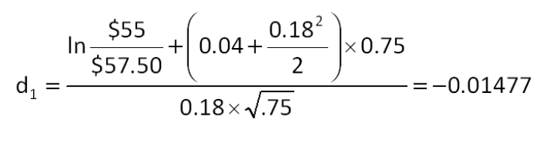

AACSB: Analytic
Bloom's: Analysis
Difficulty: Intermediate
Learning Objective: 25-2
Section: 25.2
Topic: Call option delta
65. A stock is currently selling for $36 a share. The risk-free rate is 3.8 percent and the standard deviation is 27 percent. What is the value of d₁ of a 9-month call option with a strike price of $40?
A. -0.21872
B. -0.21179
C. -0.21047
D. -0.20950
E. -0.20356
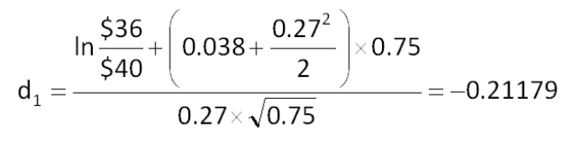

AACSB: Analytic
Bloom's: Analysis
Difficulty: Intermediate
Learning Objective: 25-2
Section: 25.2
Topic: Call option delta
66. The delta of a call option on a firm's assets is 0.767. This means that a $50,000 project will increase the value of equity by:
A. $21,760.
B. $25,336.
C. $38,350.
D. $54,627.
E. $65,189.
Increase in equity value = $50,000 × 0.767 = $38,350

AACSB: Analytic
Bloom's: Application
Difficulty: Basic
Learning Objective: 25-4
Section: 25.4
Topic: Market value of equity
67. The delta of a call option on a firm's assets is 0.727. This means that a $195,000 project will increase the value of equity by:
A. $141,765.
B. $180,219.
C. $211,481.
D. $264,909.
E. $268,226.
Increase in equity value = $195,000 × 0.727 = $141,765

AACSB: Analytic
Bloom's: Application
Difficulty: Basic
Learning Objective: 25-4
Section: 25.4
Topic: Market value of equity
68. The current market value of the assets of Smethwell, Inc. is $56 million, with a standard deviation of 16 percent per year. The firm has zero-coupon bonds outstanding with a total face value of $40 million. These bonds mature in 2 years. The risk-free rate is 4.5 percent per year compounded continuously. What is the value of d₁?
A. 1.67
B. 1.84
C. 1.93
D. 2.00
E. 2.06
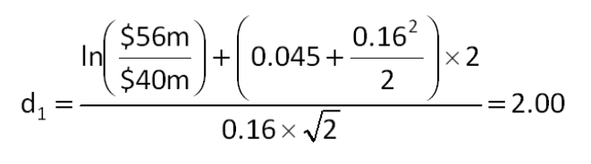

AACSB: Analytic
Bloom's: Analysis
Difficulty: Intermediate
Learning Objective: 25-4
Section: 25.4
Topic: Market value of equity
69. The current market value of the assets of Cristopherson Supply is $46.5 million. The market value of the equity is $28.7 million. The risk-free rate is 4.75 percent and the outstanding debt matures in 4 years. What is the market value of the firm's debt?
A. $17.80 million
B. $19.80 million
C. $20.23 million
D. $22.66 million
E. $23.01 million
Market value of debt = $46.5m - $28.7m = $17.8m

AACSB: Analytic
Bloom's: Application
Difficulty: Basic
Learning Objective: 25-4
Section: 25.4
Topic: Market value of debt
70. The current market value of the assets of Nano Tek is $16 million. The market value of the equity is $7.5 million. The risk-free rate is 4.5 percent and the outstanding debt matures in 5 years. What is the market value of the firm's debt?
A. $8.50 million
B. $9.98 million
C. $12.00 million
D. $19.42 million
E. $23.84 million
Market value of debt = $16m - $7.5m = $8.5m

AACSB: Analytic
Bloom's: Application
Difficulty: Basic
Learning Objective: 25-4
Section: 25.4
Topic: Market value of debt

Essay Questions
71. Explain why the equity ownership of a firm is equivalent to owning a call option on the firm's assets.
Equity is equal to asset minus liabilities. This relationship reflects the residual ownership feature of equity. Because of the limited liability feature of equity ownership in a corporation, the equity must always be non-negative in value, even if the debts of the firm exceed the value of the assets and the firm is in technical (if not outright) bankruptcy. Thus, the equity = max(A - D,0), is equal to a call option on the assets of the firm with a strike price equal to the face value of the firm's debt.
Feedback: Refer to section 25.4

AACSB: Reflective thinking
Bloom's: Comprehension
Difficulty: Basic
Learning Objective: 25-3
Section: 25.4
Topic: Option model of firm
72. Explain how option pricing theory can be used to argue that acquisitive firms pursuing conglomerate mergers are not acting in the shareholders' best interest.
Because equity can be viewed as a call option on the assets of the firm, the Black-Scholes option pricing model tells us that equity value will increase if the standard deviation of the firm's assets increases. To the extent that conglomerate mergers create a more diversified business model for the acquiring firm, the standard deviation of the assets will actually decrease, which is counter to the shareholders' interest in maximizing the value of the firm. The shareholders would prefer that managers seek out maximum risk in their business activities.
Feedback: Refer to section 25.5

AACSB: Reflective thinking
Bloom's: Analysis
Difficulty: Intermediate
Learning Objective: 25-5
Section: 25.5
Topic: Option model of firm
73. Give an example of a protective put and explain how this strategy reduces investor risk.
Students should give an example that includes the purchase of a stock and also a put. The strike price should be relatively close to the stock price. The protective put provides investors with a guaranteed selling price for their stock. Without the put, the selling value of the stock could go as low as zero.
Feedback: Refer to section 25.1

AACSB: Reflective thinking
Bloom's: Application
Difficulty: Basic
Learning Objective: 25-1
Section: 25.1
Topic: Protective put
74. Identify the five variables that affect the value of an American put option and indicate how an increase in each of the variables will affect the value of the put. Also indicate the common name, if any, given to each variable.
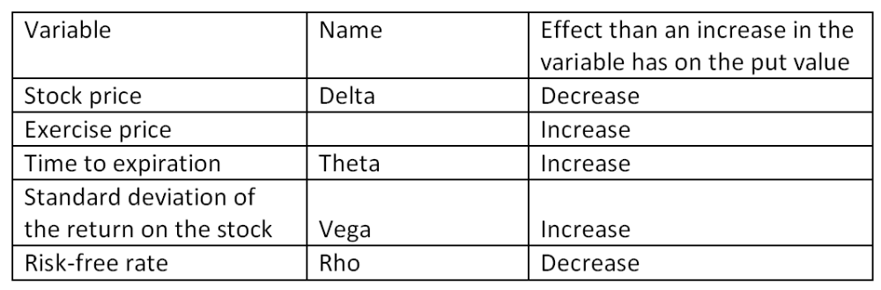
Feedback: Refer to section 25.3

AACSB: Reflective thinking
Bloom's: Knowledge
Difficulty: Basic
Learning Objective: 25-3
Section: 25.3
Topic: Option inputs
75. Explain how an increase in T-bill rates will affect the value of an American call and an American put.
An increase in the risk-free rate will increase the value of an American call option and decrease the value of an American put option. However, any change in the option value will be somewhat limited given a normal range of market interest rates.
Feedback: Refer to section 25.3

AACSB: Reflective thinking
Bloom's: Knowledge
Difficulty: Basic
Learning Objective: 25-3
Section: 25.3
Topic: Option inputs
76. Explain why financial mergers tend to benefit bondholders more than shareholders.
Financial mergers tend to lower the risk of default by lowering the volatility of the combined firm's return on assets. By lowering default risk, the value of the firm's debt rises, which in turn lowers the value of the firm's equity.
Feedback: Refer to section 25.5

AACSB: Reflective thinking
Bloom's: Comprehension
Difficulty: Basic
Learning Objective: 25-5
Section: 25.5
Topic: Financial merger

Multiple Choice Questions
77. You need $12,000 in 6 years. How much will you need to deposit today if you can earn 11 percent per year, compounded continuously? Assume this is the only deposit you make.
A. $6,000.00
B. $6,048.50
C. $6,179.25
D. $6,202.22
E. $6,415.69
PV = $12,000 × e^{-0.11(6)} = $6,202.22

AACSB: Analytic
Bloom's: Application
Difficulty: Basic
EOC #: 25-2
Learning Objective: 25-1
Section: 25.1
Topic: Continuous compounding
78. A stock is selling for $60 per share. A call option with an exercise price of $67 sells for $3.31 and expires in 4 months. The risk-free rate of interest is 2.8 percent per year, compounded continuously. What is the price of a put option with the same exercise price and expiration date?
A. $8.99
B. $9.23
C. $9.47
D. $9.69
E. $9.94
$60 + P = $67e^{-(0.028)(1/3)} + $3.31; P = $9.69

AACSB: Analytic
Bloom's: Application
Difficulty: Basic
EOC #: 25-3
Learning Objective: 25-1
Section: 25.1
Topic: Put-call parity
79. A put option that expires in eight months with an exercise price of $57 sells for $3.85. The stock is currently priced at $59, and the risk-free rate is 3.1 percent per year, compounded continuously. What is the price of a call option with the same exercise price and expiration date?
A. $6.67
B. $7.02
C. $7.34
D. $7.71
E. $7.80
$59 + $3.85 = $57 e^{-(0.031)(2/3)} + C; C = $7.02

AACSB: Analytic
Bloom's: Application
Difficulty: Basic
EOC #: 25-4
Learning Objective: 25-1
Section: 25.1
Topic: Put-call parity

80. What is the price of a put option given the following information?
A. $16.57
B. $16.83
C. $17.74
D. $18.47
E. $19.02
d₁ = [ln ($81/$88) + (0.04 + 0.64²/2) × 0.5]/[0.64 × (0.5^{1/2})] = 0.0873
d₂ = 0.0873 - [0.64 × (0.5^{1/2})] = -0.3652
N(d₁) = 0.5348
N(d₂) = 0.3575
C = $81(0.5348) - ($88e^{-0.04(0.5)}) (0.3575) = $12.48
P = $88e^{-0.04(0.5)} + $12.48 - $81 = $17.74

AACSB: Analytic
Bloom's: Analysis
Difficulty: Basic
EOC #: 25-9
Learning Objective: 25-2
Section: 25.2
Topic: Black-Scholes
81. What is the delta of a put option given the following information?
A. -0.685
B. -0.315
C. 0.315
D. 0.525
E. 0.685
d₁ = [ln ($90/$85) + (0.07 + 0.5²/2) × (10/12)]/[0.5 × (10/12)^{1/2}] = 0.4812
N(d₁) = 0.685
Put delta = 0.685 - 1 = -0.315

AACSB: Analytic
Bloom's: Analysis
Difficulty: Basic
EOC #: 25-10
Learning Objective: 25-2
Section: 25.3
Topic: Option delta
82. You own a lot in Key West, Florida, that is currently unused. Similar lots have recently sold for $1.2 million. Over the past five years, the price of land in the area has increased 10 percent per year, with an annual standard deviation of 23 percent. A buyer has recently approached you and wants an option to buy the land in the next 9 months for $1,310,000. The risk-free rate of interest is 7 percent per year, compounded continuously. How much should you charge for the option? (Round your answer to the nearest $1,000.)
A. $52,000
B. $58,000
C. $63,000
D. $72,000
E. $77,000
d₁ = [ln ($1,200,000/$1,310,000) + (0.07 + 0.23²/2) × (0.75)]/[0.23 × (0.75^{1/2})] = -0.077157
d₂ = -0.077157 - [0.23 × (0.75^{1/2})] = -0.2763
N(d₁) = 0.4693
N(d₂) = 0.3911
C = $1,200,000(0.4693) - ($1,310,000e^{-0.07(0.75)}) (0.3911) = $76,909.55 ≈ $77,000

AACSB: Analytic
Bloom's: Analysis
Difficulty: Basic
EOC #: 25-11
Learning Objective: 25-4
Section: 25.4
Topic: Black-Scholes and asset value
83. A call option with an exercise price of $31 and 6 months to expiration has a price of $3.77. The stock is currently priced at $17.99, and the risk-free rate is 3 percent per year, compounded continuously. What is the price of a put option with the same exercise price and expiration date?
A. $13.89
B. $14.57
C. $15.24
D. $15.69
E. $16.32
$17.99 + P = $31e^{-0.03(0.5)} + $3.77; P = $16.32

AACSB: Analytic
Bloom's: Application
Difficulty: Basic
EOC #: 25-14
Learning Objective: 25-1
Section: 25.1
Topic: Put-call parity
84. A call option matures in nine months. The underlying stock price is $95, and the stock's return has a standard deviation of 19 percent per year. The risk-free rate is 3 percent per year, compounded continuously. The exercise price is $0. What is the price of the call option?
A. $15.97
B. $52.14
C. $56.37
D. $92.23
E. $95.00
If the exercise price is equal to zero, the call price will equal the stock price, which is $95.

AACSB: Analytic
Bloom's: Analysis
Difficulty: Intermediate
EOC #: 25-15
Learning Objective: 25-2
Section: 25.2
Topic: Black-Scholes
85. A stock is currently priced at $45. A call option with an expiration of one year has an exercise price of $60. The risk-free rate is 14 percent per year, compounded continuously, and the standard deviation of the stock's return is infinitely large. What is the price of the call option?
A. $39.47
B. $42.08
C. $45.00
D. $52.63
E. $60.00
If the standard deviation is infinite, d₁ goes to positive infinity so N(d₁) goes to 1, and d₂ goes to negative infinity so N(d₂) goes to 0. In this case, the call price is equal to the stock price, which is $45.

AACSB: Analytic
Bloom's: Application
Difficulty: Basic
EOC #: 25-17
Learning Objective: 25-2
Section: 25.2
Topic: Black-Scholes
86. Sunburn Sunscreen has a zero coupon bond issue outstanding with a $10,000 face value that matures in one year. The current market value of the firm's assets is $10,600. The standard deviation of the return on the firm's assets is 40 percent per year, and the annual risk-free rate is 7 percent per year, compounded continuously. What is the market value of the firm's debt based on the Black-Scholes model? (Round your answer to the nearest $100.)
A. $6,415.30
B. $6,900
C. $8,300
D. $8,800
E. $9,200
d₁ = [ln ($10,600/$10,000) + (0.07 + 0.4²/2) × 1]/[0.4 × (1^{1/2})] = 0.5207
d₂ = 0.5207 - [0.4 × (1^{1/2})] = 0.1207
N(d₁) = 0.6987
N(d₂) = 0.5480
Equity = $10,600(0.6987) - ($10,000e^{-0.07(1)}) (0.548) = $2,296.50
Debt = $10,600 - $2,296.50 = $8,303.50 ≈ $8,300

AACSB: Analytic
Bloom's: Analysis
Difficulty: Intermediate
EOC #: 25-18
Learning Objective: 25-4
Section: 25.4
Topic: Equity as an option
87. Frostbite Thermal Wear has a zero coupon bond issue outstanding with a face value of $20,000 that matures in one year. The current market value of the firm's assets is $23,000. The standard deviation of the return on the firm's assets is 52 percent per year, and the annual risk-free rate is 6 percent per year, compounded continuously. What is the market value of the firm's equity based on the Black-Scholes model? (Round your answer to the nearest $100.)
A. $6,400
B. $6,700
C. $6,900
D. $7,000
E. $7,200
d₁ = [ln ($23,000/$20,000) + (0.06 + 0.52²/2) × 1]/[0.52 × (1^{1/2})] = 0.6442
d₂ = 0.6442 - [0.52 × (1^{1/2})] = 0.1242
N(d₁) = 0.7403
N(d₂) = 0.5494
Equity = $23,000(0.7403) - ($20,000e^{-0.06(1)}) (0.5494) = $6,677.86 ≈ $6,700

AACSB: Analytic
Bloom's: Analysis
Difficulty: Basic
EOC #: 25-20
Learning Objective: 25-4
Section: 25.4
Topic: Equity as an option

